Membership Application Form
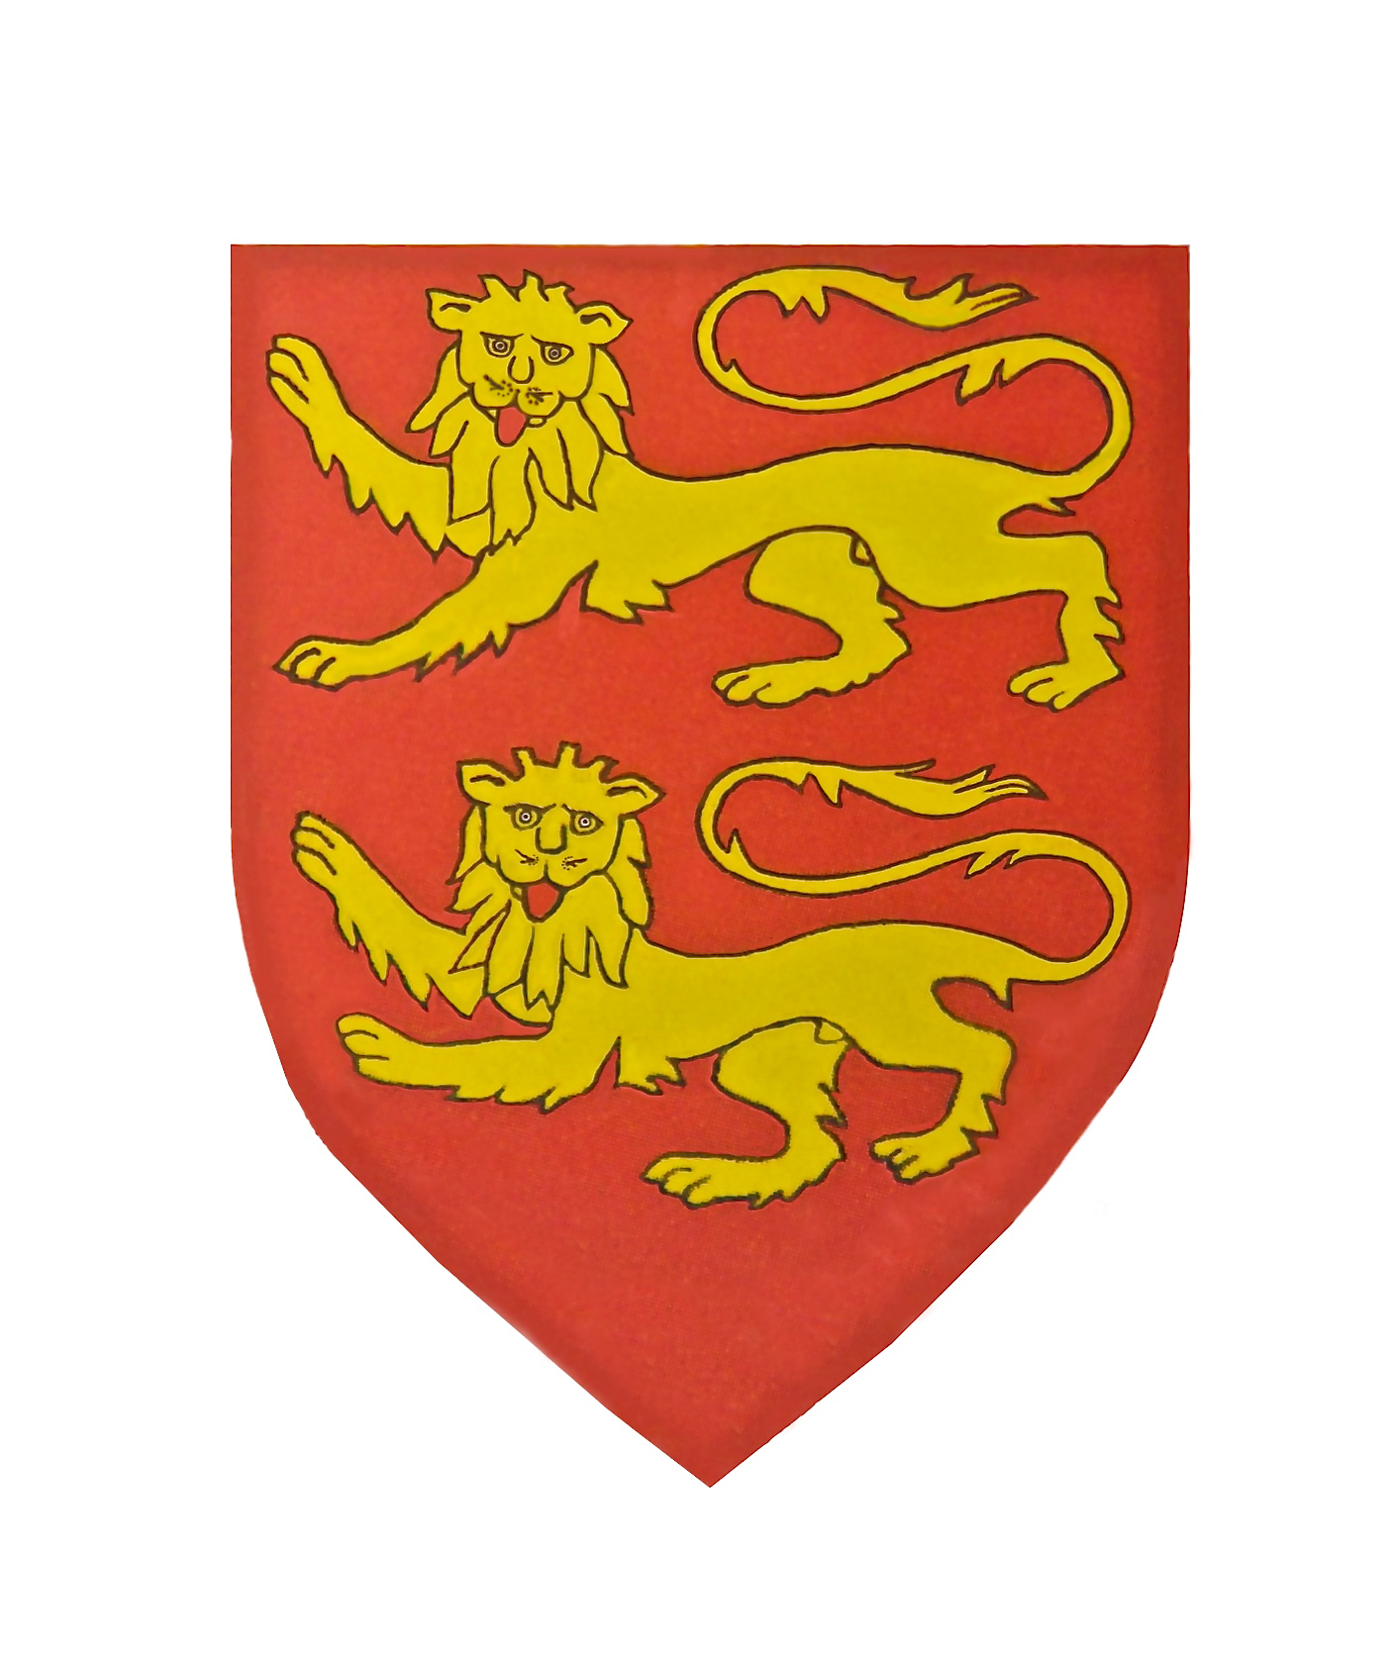
(Please PRINT in Capitals) Date ………….

Name of Applicant (s) ………………………………...

…………………………………………………………..

Address ………………………………………………..

…………………………………………………………..

Post Code ……………… Tel No …………………….

E-mail …………………………………………………..

Occupation …………………………………………….

Cultural Interests ………………………………………

Would you consider your knowledge of the French language to be – slight/medium/fluent

How did you hear about Souvenir Normand?

…………………………………………………………..

Could you assist the British Section by providing :-

Interpreting Computer/Admin. Support

Presentations/Talks to members

Entertaining/Catering Car Lifts to meetings

Advertising/Promotion/ Website

Any other skills ………………………………………

<<<<>>>>

Please return this completed form to: -

Mrs. Jenny Muir
Rowallan, 38 Starrs Mead
Battle TN33 0UG

Annual Membership fees

Full rate £ 25 pa

Senior rate (over 65 years) £ 15 pa

Payment

If you would like to pay by Standing Order please complete the form below: -

Please pay to: Lloyds Bank Ltd.
Hastings Branch
Sort Code: 30-97-66

For the account of the Souvenir Normand

Account Ref …………………..…...
(Applicant’s name)

Amount to be charged: £ ………..

And annually thereafter on 1st November

Name of your Bank …………………………

Account No ………………………………….

Sort Code ……………………………………

Name and Title ……………………………..

………………………………………………..

Signature ……………………………………

Please indicate if you are paying by cheque

Or by Standing Order

Please make your cheque out to: -
“Souvenir Normand”

Souvenir Normand

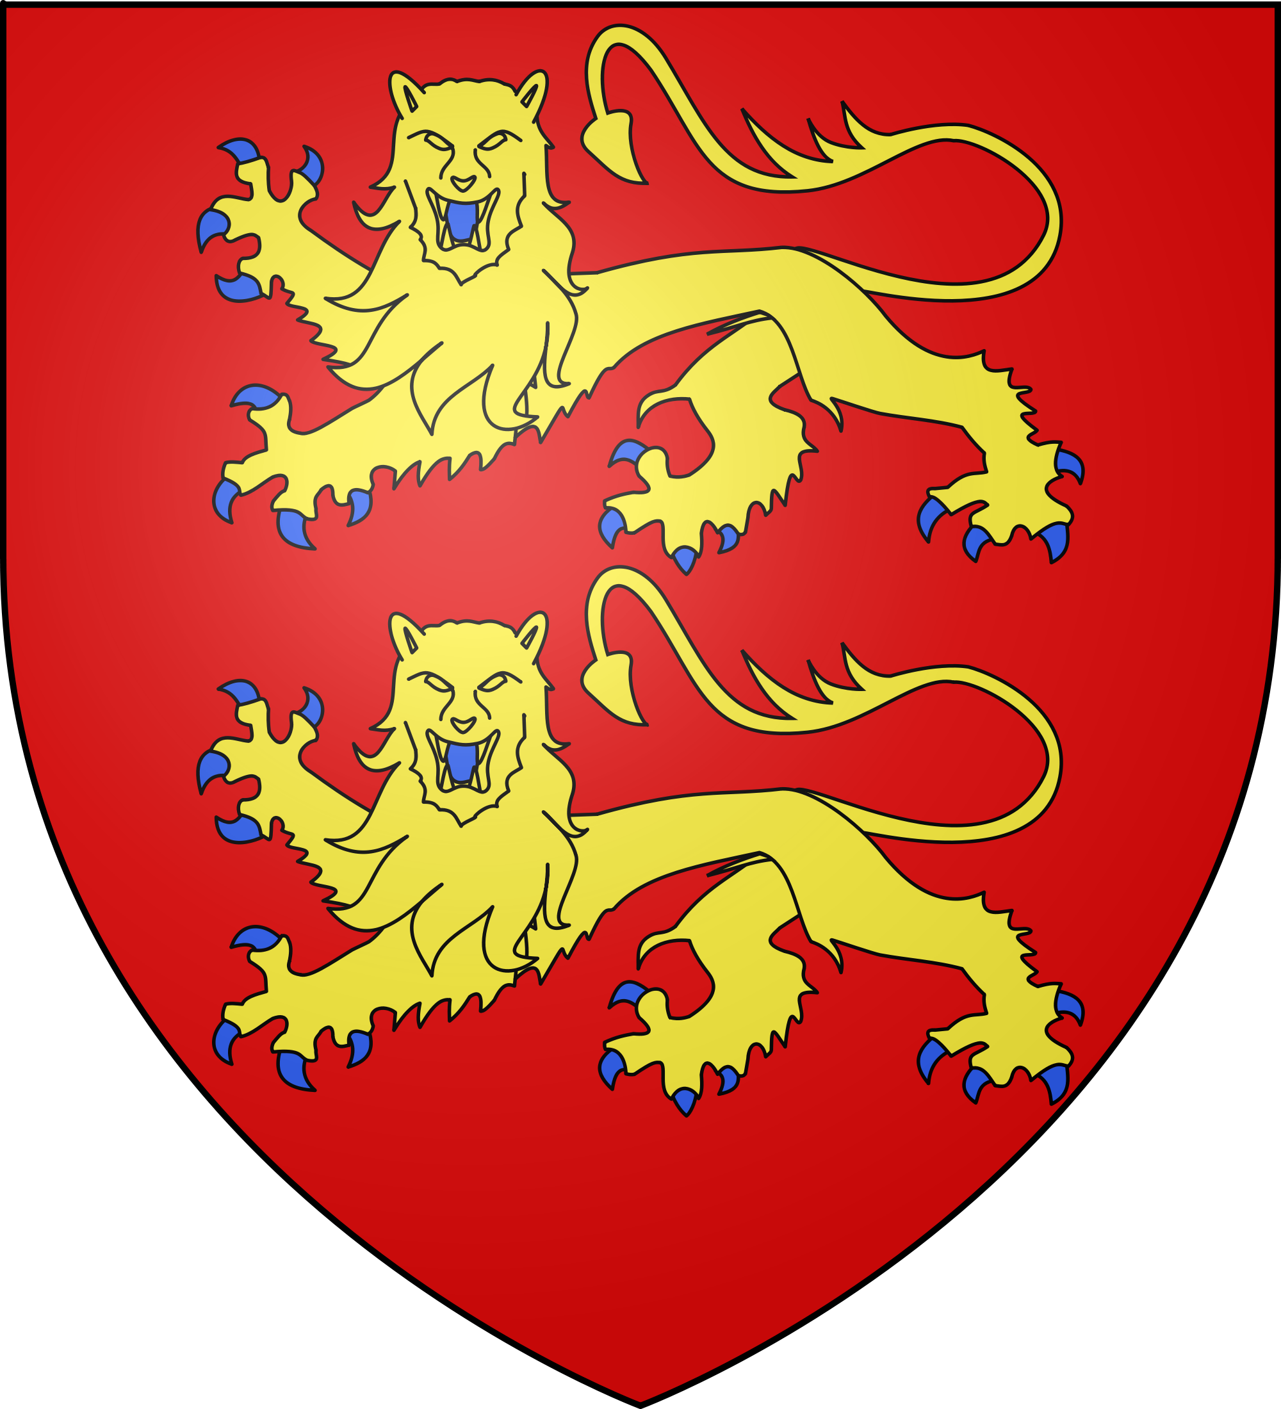

Invites you to become
a member

We are a non-political Society formed in 1896 with the purpose of furthering friendship between people in France, Great Britain, Norway, Canada and other countries, particularly in those regions where the Norman influence has been prominent.

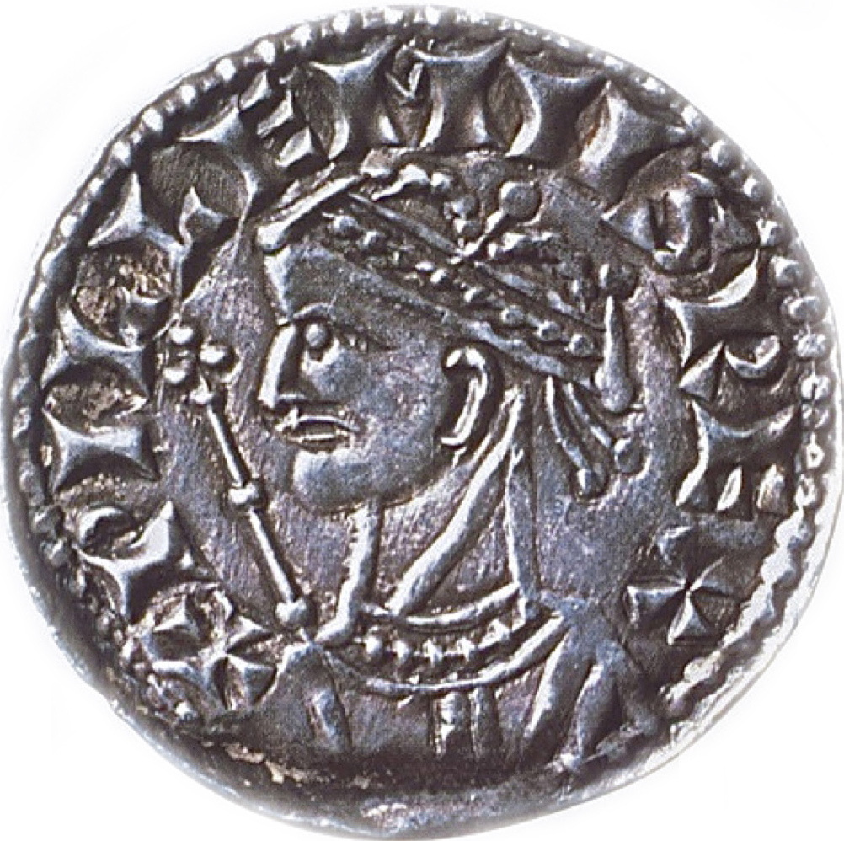

A penny coin depicting
William the Conqueror

